

**CODING LAB**

**Group Project**

**Project Title: Website of restaurant “Valhalla”**

Students: Ablay Akhmetov, Kamilla Ten, Sanzhar Karibay

Tutor’s name: Salkenov Aldiyar

Date: 21.04.2021

Nur-Sultan 2021

Table of Contents

**Chapter I: Introduction** ..................................................................................................................... 2

**1.1** Introduction 3

**1.2** Project goals 3

**1.3** Project relevance 3

**1.4** Target audience 3

**1.5** Similar projects 4

**1.6** Methodology Development Model 4

**1.7** Team information 5

**1.8** Communication strategy 6

**Chapter II: Project** .............................................................................................................................. 6

**2.1** Project features 6

**2.2** Budget 6

**2.3** Design 7

**2.4** Tools and Technique 7

**2.5** Future problems 7

**2.6** Time table 8

# **1.1** Introduction

Online restaurant management system is the process of ordering food from a website. The food has the ability to be ready just in time when the customer comes. The purpose of the development of the Internet Restaurant Management is:

to change the usual method of applications by a computerized system. It is also convenient to receive a sales report in pdf format at any time.

Online restaurant management contains quite broad capabilities. This plan can be used by any restaurant or fast food for buyers to keep track of their own orders. Online Restaurant Management uses PostgreSQL Server as a backend, so there is almost no chance of data loss or data security. The customer is obliged to select the food he wants, then add it to the basket and choose deliverying or booking space in the restaurant. If he chooses deliverying, he will pay when he receives food, but if the customer chooses a booking, he is obliged to pay 50% of the cost. Thereafter, the payment is executed by credit or debit card payment method or in cash at the restaurant.The site also provides all information about the delivery: delivery time, location of the supplier.

# **1.2** Project goals

The main idea and uniqueness of the project is the possibility of free choice. The goal of this project is to automate the activities of a cafe based on an informal approach, as well as gain skills in implementing this approach, designing and implementing content.

# **1.3** Project relevance

How many times have you come to a cafe or restaurant, whether alone or with your family, and they tell you that all the seats are taken? Or how many times have you been informed that your lovely meal is ran out of stock or will only be cooked in 40-60 minutes? We chose this topic because we ourselves often face this problem, that we were so tired of it that we decided to take everything into our own hands and provide an opportunity to avoid them.

# **1.4** Target audience

We will target catering directors. even if our project will be used by ordinary consumers, our main audience, to which we will sell our work, is the restaurants themselves. Because in order for our site to work, we need a product in the form of food and a cook in the form of restaurant employees. To be specific, we do not need to take restaurants where the occupancy rate of customers exceeds the norm based on the fact that our project will book seats, because we have created additional functions (more on this in the next sections). Thanks to this, we can search for absolutely any cafes or restaurants, whether they are brand new or giants in the catering market.

# **1.5** Similar projects

We found a restaurant which is similar with our project, the name of this restaurant is “U-Afanasicha”. This restaurant placed in the Almaty city, so we will be first in Nur-Sultan.

https://u-afanasicha.kz/ , this site has the same structure and features that we want to add to our project. To implement the main services and functions of our site, as well as to collect data about how visitors interact with our site, products and services, we use this site as an example.

# **1.6** Methodology Development Model



The sequential phases in Waterfall model are −

**Requirement Gathering and analysis** − All possible requirements of the system to be developed are captured in this phase and documented in a requirement specification document.

* System Design − The requirement specifications from first phase are studied in this phase and the system design is prepared. This system design helps in specifying hardware and system requirements and helps in defining the overall system architecture.
* Implementation− With inputs from the system design, the system is first developed in small programs called units, which are integrated in the next phase. Each unit is developed and tested for its functionality, which is referred to as Unit Testing.
* Integration and Testing − All the units developed in the implementation phase are integrated into a system after testing of each unit. Post integration the entire system is tested for any faults and failures.
* Deployment of system − Once the functional and non-functional testing is done; the product is deployed in the customer environment or released into the market.
* Maintenance− There are some issues which come up in the client environment. To fix those issues, patches are released. Also to enhance the product some better versions are released. Maintenance is done to deliver these changes in the customer environment.

# **1.7** Team information

**Ablay** will be engaged in the design of the site and also with its documentation (presentation, script, and so on)

**Sanzhar** will be in the form of a front-end developer, or rather, a site layout.

**Кamilla** will be working with the backend, in other words the backend developer.

But at this pace of work, there are also problems, since the work will not begin until the previous one does their own. Until Ablay completes the design - Sanzhar won't be able to start making it up, and until the site is ready - Kamilla won't be able to make the server part. Therefore, it was decided that we will also help each other in order to speed up and optimize our work as much as possible, but part of the work still remains with one person.

# **1.8** Communication strategy

Because of online format, usually we use application Discord. We meet everyday after some break our lessons. In addition, we have Telegram group chat, where we can discuss any time and provide some ideas.

The link to our Github repository:

<https://github.com/abldabl/cafe.git>

# **2.1** Project features

You just have to book a table. The administrator will instantly receive a reservation request. Want a table by the window? Indicate this in your wishes. We will book it for you. Don`t want to wait a long time for your order in a noisy cafe? order it in advance by specifying the desired time and enjoy a freshly prepared meal at your preferred table.

We did not just want to be different from many other restaurants, we wanted to provide the residents of the capital with something really interesting and new.

Indeed, at the moment, few restaurants offer such services. Whether sitting comfortably at one of the tables, calling us to make an order or placing it on the website, you will enjoy the taste of your favorite dishes, which our chefs will prepare for you with love. The analysis of the cafe's work allows you to identify key concepts, find out the tasks that need to be solved within the project, and analyze the functional requirements of the future product.

# **2.2** Budget

Cause our web site is not so difficult in design part, because it is ordinary site of restaurant, payment for front end will be not so big.

For the website projects we have 3 types of payment:

1) Money for the website itself: logo, domain, hosting, etc. ~ 50,000 tenge

2) Money for front end developers ~ 20,000 tenge

3) Money for back end developers ~30,000 tenge

**Total amount**: ~100,000 tenge

# **2.3** Design

Fast and convenient website for ordering food and booking tables online. It is full of content - various information, juicy photos. Attention to detail is observed. The user literally gets acquainted with the institution, delves into its history and philosophy. The page is divided into thematic logical blocks. Everything is as it should be for a selling site. If you are a person who loves different cultures' delicious, then you can choose our Cafe, due to we have a combined kitchen. Order food from the restaurant without leaving your home or office. In addition to this, you can choose dishes and also order them, so that upon arrival at the cafe you can immediately enjoy the food, so this feature makes us competitive.

# **2.4** Tools and Technique

a. HTML

b. Bootstrap

c. Css

d. PostgreSQL

e. Node JS

f. Sublime text

g. Git hub

h. Java Script

# **2.5** Future problems

During developing this project we found out some future problems. Protection of data. This is very important part of our project due to after making an order a client will have to write his card data to pay for his order and it must be protected.

Hooligans, who can make an order for whole menu and don't pay for it, so cafe can loose the profit. For this we decided to make clients pay 30% of their order before the cafe chef starts to cook it.

Problems with customers who have not booked a seat. There can be a troubles between clients who have and have not book a place. For example, a client came to an establishment, and there seems to be a place, but in fact, in 30 minutes the person who booked it will come. We are still working on this issue as we haven’t found a better solution.

Analysis of the cafe project allows us to identify key concepts, find out the tasks that need to be solved within the project, analyze the functional requirements of the future project and a set of functions provided by the program) and non-functional (reliability, efficiency)

# **2.6** Time table

|  |  |  |  |  |
| --- | --- | --- | --- | --- |
| **Week** | **Tasks** | **Expected start date** | **Finishing date** | **Responsible team member** |
| Week 3 | Milestone 1  Milestone 2 | 19/04/2021  22/04/2021 | 21/04/2021  25/04/2021 | Ablay  Sanzhar |
| Week 4 | Milestone 3  Milestone 4  Milestone 5 | 26/04/2021  29/04/2021  26/04/2021 | 28/04/2021  02/05/2021  02/05/2021 | Ablay  Sanzhar  Kamilla Sanzhar |
| Week 5 | Milestone 6 | 03/05/2021 | 07/05/2021 | Kamilla |
| Week 6 | Milestone 7 | 10/05/2021 | 16/05/2021 | Ablay  Kamilla Sanzhar |
| Week 7 | Milestone 8 | 17/05/2021 | 23/05/2021 | Ablay  Kamilla Sanzhar |

* **Milestone 1**: Design and start of development of website visuals. We want to create carcass of our site on some constructor web sites, to understand what kind of site it will be. Search for suitable images of food, divide content of pages, compare with other web sites of Kazakhstan restaurants. Component planning: organize how many pages will be on the site, such as “contact us”, “about” and etc.

* **Milestone 2**: After some fixes of fundament of web site, start of frontend and in the evening there will be a conference for discussion/help to each other on the project.

* **Milestone 3**: Make kind of survey from out friends and family to understand what type of mistakes we did or what should we do to make design of web site more pleasing to the eye.

* **Milestone 4**: Starting to plan about how many tables will be in database (MySQL) and create ER diagram of our database, after this finish with normalization of it.

* **Milestone 5**: Beginning of backend and organizing online conference and finishing main page of website.

* **Milestone 6**: Testing codes: we will test our main page with connectivity with Node JS and with database.

* **Milestone 7**: Complete all other pages (“menu”, “contact us”, “about restaurant”) and connect between each other, also check it on Node JS.

* **Milestone 8**: Finishing web site and set all the features: booking, payment. Prepare for presentation.

**ERD of database:**

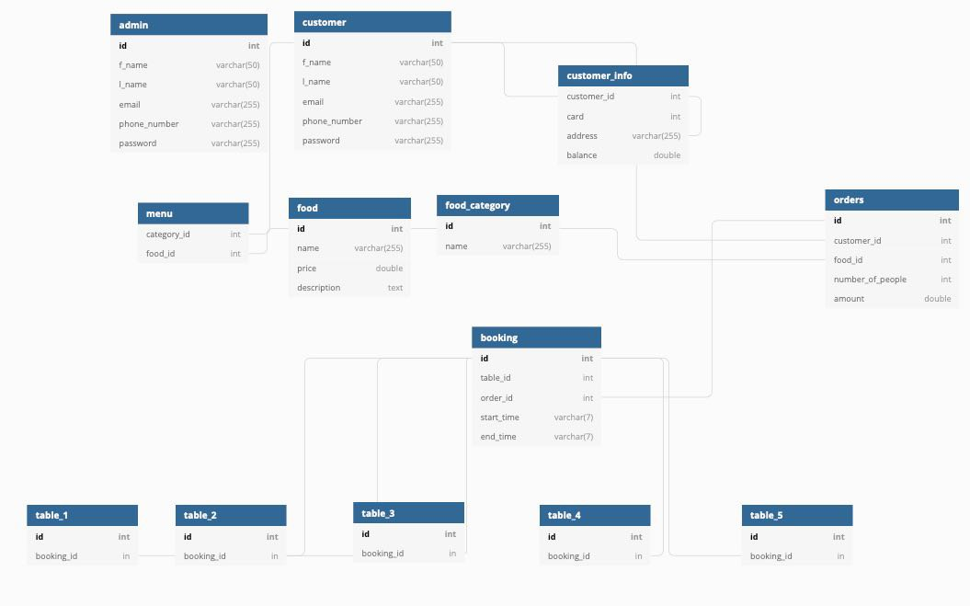

There are 13 tables in the database. Every of them plays it`s own role in a big job.

**Responsibility of tables:**

**Admin –** there are main information about admins of the website, so they can log in the site and manipulate with menu, price of food, look at the report and etc.

**Customer –** clients are able not to register in the website, but if they don`t, they will not have a cashback from every order and will write their card data or address every time.

**Customer_info –** clients` private information, such as: card data, address, and balance in the site are put separately to hide and protect it.

**Food_category –** our restaurant has a combined kitchen, so it has different categories of food.

**Food –** every food in the restaurant has it`s own id, name and price.

**Menu -** here food is sorter into categories, thereby making the menu.

**Orders –** every order has it`s own id, because it will be easier to book a place, more details below, and also it`s convenient to count how much profit the restaurant has.

**Booking –** customer has to choose a time when he wants to book a place, and then we check if there are free tables.

**Tables –** there are 5 tables at the beginning, each of them has it`s own table in the database, because it`s really more comfortable to find free places.

**NOTE:** Had one problem with database. In the beginning we wanted to create a column ‘table’ into the table ‘booking’ and it had to be a foreign key, so we couldn`t make a connection between one foreign key and five primary keys(5 table in the restaurant). Then it was decided, that when client chooses a table in the website, it will automatically inserted into the table ‘table_*number*’.

It will work like – client has 3 options: booking, delivery, menu. If he chooses the booking, then he will have to choose a table and time, when he wants to come, after that makes an order for food and in the end pays 50% of cost. But if he chooses the delivery, he will have a menu to order, and then he writes his address and card for pay.